South Australia
Adelaide Oval Redevelopment and Management Act 2011
An Act to facilitate the redevelopment of Adelaide Oval; to provide for the future care, control and management of Adelaide Oval and its precincts; and for other purposes.

Contents
Part 1—Preliminary
1 Short title
2 Commencement
3 Interpretation
Part 2—Adelaide Oval Core Area
4 Lease to be granted to Minister
5 Sublease to SMA
6 Sinking fund
Part 3—Adelaide Oval Licence Area
7 Licence to Minister
Part 4—Financial management
8 Extent of financial commitment
9 Financial supervision by the Auditor-General
Part 5—Development assessment
10 Development assessment
Part 6—Miscellaneous
11 Interaction with other Acts
12 Council leases, licences and approvals in adjacent area
13 Status of land as park lands
14 Victor Richardson Road
15 Public Transport Plan for Adelaide Oval
16 Identification of land
17 Duties of Registrar-General and other persons
18 Special annual sublease fee
19 Interim occupation of core area
20 Temporary use of adjacent area during construction period
21 Regulations
Schedule 1—Adelaide Oval Core Area—Overall plan
Schedule 2—Eastern Grandstand Area
Schedule 3—Southern Area
Schedule 4—Northern Area
Schedule 5—Car parking area
Legislative history

The Parliament of South Australia enacts as follows:
Part 1—Preliminary
1—Short title
This Act may be cited as the Adelaide Oval Redevelopment and Management Act 2011.
2—Commencement
This Act will come into operation on a day to be fixed by proclamation.
3—Interpretation
In this Act, unless the contrary intention appears—
Adelaide Oval Core Area means any land constituting or within—
(a) Section 1726, Hundred of Yatala; and
(b) the Eastern Grandstand Area; and
(c) the Southern Area; and
(d) the Northern Area; and
(e) the land referred to in section 14;
Adelaide Oval Licence Area means any land constituting or within Section 1626, Hundred of Yatala other than—
(a) land within the Adelaide Oval Core Area; or
(b) land that is laid out (on the commencement of this Act) as Light’s Vision on the corner of Pennington Terrace and Montefiore Road, North Adelaide; or
(c) land that, immediately before the commencement of this Act, constitutes the Creswell Gardens or the Pennington Gardens West; or
(d) land that, immediately before the commencement of this Act, is subject to a lease or licence to the Memorial Drive Tennis Club Inc., Next Generation Clubs Australia Pty Ltd or the South Australian Tennis Association Inc.;
Council means The Corporation of the City of Adelaide;
development means development within the meaning of the Development Act 1993;
Eastern Grandstand Area means the areas designated by the letters A, B, C, D1, D2 and D3 according to the maps set out in Schedule 1 and Schedule 2;
football means Australian Rules football;
Northern Area means the area designated by the letter F according to the maps set out in Schedule 1 and Schedule 4;
SACA means the South Australian Cricket Association Incorporated;
SANFL means the South Australian National Football League Inc.;
SMA means Adelaide Oval SMA Limited;
Southern Area means the area designated by the letter E according to the maps set out in Schedule 1 and Schedule 3.

Part 2—Adelaide Oval Core Area
4—Lease to be granted to Minister
(1) The Council must, at the request of the Minister, grant a lease to the Minister over all of the Adelaide Oval Core Area, or any part of that area specified by the Minister.
(2) A lease must be granted by the Council under subsection (1) within 30 days after the making of the request by the Minister (or such longer period as the Minister may allow).
(3) Subject to this section, a lease under subsection (1)—
(a) must be for a term specified by the Minister (being a term of up to 80 years including any right to an extension or renewal); and
(b) will only be subject to such terms and conditions as the Minister may specify after consultation with the Council.
(4) The Adelaide Oval Core Area must be used predominantly for the purposes of a sporting facility (including related uses and with recreational, entertainment, social and other uses being allowed on an ancillary or temporary basis from time to time).
(5) It will be taken to be a term of a lease under subsection (1) that the Minister must ensure—
(a) that the area constituting the Adelaide Oval Core Area continues to be named Adelaide Oval; and
(b) that the Adelaide Oval Scoreboard is maintained in good condition where it stands on the commencement of this Act; and
(c) that at least 1 200 square metres of grassed open space is kept at the northern end of Adelaide Oval (between the scoreboard and the western stands).
(6) However, subsection (5)(c) does not prevent the placing of a building or other structure on any open space maintained for the purposes of that subsection—
(a) on a temporary basis for a period not exceeding 1 month; or
(b) on a temporary basis for the purposes of a special event or activity prescribed by the regulations for the purposes of this paragraph.
(7) The Minister (or any other person) must not remove or substantially alter any Moreton Bay fig tree (ficus macrophylla) located within the Adelaide Oval Core Area without the approval of the Council (which approval must not be unreasonably withheld).
(8) A lease under this section (and any use of land under a lease) is not subject to Chapter 11 of the Local Government Act 1999 or section 21 of the Adelaide Park Lands Act 2005.
(9) When a lease is granted under this section, any lease between the Council and SACA that relates to any part of the Adelaide Oval Core Area is extinguished (without giving rise to an entitlement to compensation or relief on the part of the Council or SACA by virtue of the operation of this section).
(10) Except to the extent provided by this section and section 5, the Minister is authorised to manage any part of the Adelaide Oval Core Area that is subject to a lease under this section in such manner as the Minister thinks fit.
5—Sublease to SMA
(1) The Minister is authorised to grant a sublease to SMA over any part of the Adelaide Oval Core Area that is subject to a lease under section 4.
(2) A sublease granted to SMA under this section may be for any period not exceeding the term of the head lease (including any right to an extension or renewal).
(3) The consent of the Council is not required before the Minister grants a sublease under this section.
(4) A sublease under this section must be subject to the rights of SACA and the SANFL set out in licences granted by the Minister that provide certain rights to unrestricted and exclusive use of Adelaide Oval—
(a) in the case of SACA—for purposes associated with the playing of cricket at Adelaide Oval during designated periods of the year; and
(b) in the case of the SANFL—for purposes associated with the playing of football during designated periods of the year.
(5) Subject to subsection (4), a sublease under this section may make such provision as the Minister thinks fit with respect to the use or management of the Adelaide Oval Core Area and may allow for any further sublease or licence over any part of the area (subject to the consent of the Minister and subject to the other provisions of this Act and to the provisions of the relevant head lease).
(6) The Minister must, within 6 sitting days after a sublease is granted to SMA under this section, cause copies of the sublease to be laid before both Houses of Parliament.
(7) The Minister must, within 6 sitting days after a licence is granted for the purposes of subsection (4), cause copies of the licence to be laid before both Houses of Parliament.
(8) For the purposes of this section, the designated periods are as follows:
(a) in relation to SACA—a period commencing on 8 October in each year and expiring on 14 March in the next year (both dates inclusive);
(b) in relation to the SANFL—a period commencing on 15 March in each year and expiring on 7 October in the same year (both dates inclusive),
or such other periods as may be agreed between SACA and the SANFL.
(9) A sublease under this section (and any use of land under a sublease) is not subject to Chapter 11 of the Local Government Act 1999 or section 21 of the Adelaide Park Lands Act 2005.
(10) The Minister must grant a sublease to SMA under this section by 15 March 2012.
6—Sinking fund
(1) SMA must, as soon as practicable after the grant of a sublease under section 5, establish a sinking fund out of which may be paid non-recurrent expenditures associated with the sublease.
(2) SMA must keep proper accounts of the revenues and expenditures of the sinking fund.
(3) SMA must, before 1 September in each year, report to the Minister—
(a) the amount of money paid into, and out of, the sinking fund during the financial year ending on the preceding 30 June; and
(b) the amount of money proposed to be paid into, and out of, the sinking fund during the current financial year.
(4) As soon as practicable after receipt of the report from SMA, the Treasurer must, after consultation with SMA, approve or determine the amount of money to be paid into the sinking fund during the current financial year (and SMA must comply with any determination of the Treasurer).
(5) The Auditor-General may at any time and must, at least once in every year, (and without further authorisation) audit the accounts of the sinking fund and examine the matters to be dealt with under subsections (3) and (4).
(6) The Auditor-General may, for the purpose of subsection (5), exercise any power that the Auditor-General has in relation to an audit or examination under Part 3 of the Public Finance and Audit Act 1987 (and that Part will apply in relation to the exercise of any such power under this section as if the power were exercised under that Act and as if any reference to a public authority included a reference to SMA).
(7) If an audit or examination by the Auditor-General under subsection (5) indicates that—
(a) SMA has not complied with a determination of the Treasurer under subsection (4); or
(b) money has been paid out of the sinking fund for a purpose other than non-recurrent expenditure associated with the lease,
the Auditor-General must prepare a report on the matter and deliver copies of the report to the President of the Legislative Council and the Speaker of the House of Assembly.
(8) When the President of the Legislative Council and the Speaker of the House of Assembly receive a report from the Auditor-General under this section, the President and the Speaker must—
(a) immediately cause the report to be published; and
(b) lay the report before their respective Houses at the earliest opportunity.
(9) If the President of the Legislative Council or the Speaker of the House of Assembly is absent at the time the Auditor-General delivers to the Parliament a report under this section, the Clerk of the relevant House will receive the report on behalf of the President or Speaker (as the case may be) (and the report or document will then be taken to have been received by the President or the Speaker).
(10) If a report is received by the President of the Legislative Council or the Speaker of the House of Assembly at a time when Parliament is not sitting, the report will be taken to have been published under subsection (8)(a) at the expiration of 1 clear day after the day of receipt of the report.
(11) A report or document will, when published under subsection (8)(a), be taken for the purposes of any other Act or law to be a report of the Parliament published under the authority of the Legislative Council and the House of Assembly.
(12) In this section—
non-recurrent, in relation to expenditure, means expenditure for a particular purpose that is normally made less frequently than once a year.

Part 3—Adelaide Oval Licence Area
7—Licence to Minister
(1) The Council must, at the request of the Minister, grant a licence to the Minister over all of the Adelaide Oval Licence Area, or any part of that area specified by the Minister.
(2) A licence must be granted by the Council under subsection (1) within 30 days after the making of the request by the Minister (or such longer period as the Minister may allow).
(3) A licence under this section—
(a) must be for a term specified by the Minister (being a term of up to 20 years); and
(b) must, at the request of the Minister, be extended or renewed for 1 or more periods of up to 20 years at a time subject to the qualification that the total term of a licence under this section must not exceed 80 years; and
(c) subject to subsections (4) and (5), will only be subject to such terms and conditions as the Minister may specify after consultation with the Council.
(4) If the Council considers, at the time that a licence under this section is granted, extended or renewed, that the Minister is acting unreasonably in relation to the terms and conditions to be specified under subsection (3)(c), the Council may apply to the Development Assessment Commission for a review.
(5) The Development Assessment Commission may, on application under subsection (4)—
(a) determine whether or not a term or condition, or a proposed term or condition, is reasonable; and
(b) subject to a determination under paragraph (a), direct—
(i) that a term or condition of the licence be varied or revoked; or
(ii) that the licence be subject to a term or condition specified by the Development Assessment Commission; or
(iii) that any related action be taken,
(and a direction under this paragraph will have effect according to its terms).
(6) A licence under this section authorises the Minister (or the holder of a sub-licence under this section) to use the land subject to the licence (or sub-licence) for the purposes of—
(a) providing car parking on grassed areas within a park-like setting in association with events at Adelaide Oval or Adelaide Oval No 2, or otherwise in accordance with the regulations; or
(b) providing reasonable access (including vehicular access) to any part of the Adelaide Oval Core Area; or
(c) activities that are ancillary to the redevelopment of Adelaide Oval or Adelaide Oval No 2; or
(d) activities that are ancillary to the use of Adelaide Oval or Adelaide Oval No 2 and take place—
(i) on a temporary basis for a period not exceeding 1 month; or
(ii) on a temporary basis for the purposes of a special event or activity prescribed by the regulations for the purposes of this paragraph; or
(e) providing facilities for the playing and watching of sport; or
(f) any other activity prescribed by the regulations for the purposes of this paragraph.
(7) The Minister may, after consultation with the Council, grant a sub-licence over any land that is subject to a licence between the Minister and the Council under this section.
(8) Public car parking provided under subsection (6)(a) must be limited to the area designated by the letter G according to the map set out in Schedule 5.
(9) Subsection (6)(e) only applies in relation to Adelaide Oval No 2.
(10) Subject to subsections (11), (12) and (13), any use of land under a licence (or sub-licence) under this section, and any associated works on land subject to the licence, will be subject to the provisions of the Council's management plan under Chapter 11 of the Local Government Act 1999 that relate to the Adelaide Oval Licence Area.
(11) If, after 1 July 2011, the management plan referred to in subsection (10) is amended or is revoked and replaced by a new management plan, the amendment or the new plan (as the case may be) will not apply under subsection (10) unless the Minister agrees (and until the Minister so agrees, the management plan as in force before the amendment or revocation will continue to apply under subsection (10) as if it had not been so amended or revoked).
(12) If—
(a) the Minister considers—
(i) that a provision of a management plan that applies under subsection (10) is unreasonable in connection with the use of any part of the Adelaide Oval Licence Area; or
(ii) that the Council is acting unreasonably in relation to the administration or implementation of the management plan; or
(b) the Council considers that the Minister is acting unreasonably in refusing to agree to an amendment or new management plan under subsection (11),
the Minister or the Council (as the case may be) may apply to the Development Assessment Commission for a review of the matter.
(13) The Development Assessment Commission may, on application under subsection (12)—
(a) determine whether or not a provision of the relevant management plan or an act of the Council or the Minister (as the case may be) is reasonable; and
(b) subject to a determination under paragraph (a)—
(i) direct—
(A) that a provision of the relevant management plan be varied or revoked; or
(B) that a decision of the Council be varied or revoked or that a different decision be made; or
(C) that the Minister agree with an amendment to the relevant management plan or to a new management plan; or
(D) that any related action be taken,
(and a direction under this subparagraph will have effect according to its terms and despite the provisions of Chapter 11 of the Local Government Act 1999 or the Adelaide Park Lands Management Strategy under the Adelaide Park Lands Act 2005); or
(ii) confirm any act or decision of the Council or the Minister to be reasonable in the circumstances.
(14) In connection with a licence under this section, the Minister, or a person authorised by the Minister, may carry out works on land subject to the licence (including by undertaking excavations, changing the form of any land, and forming paths or access roads).
(15) Without limiting any other power of the Minister under a sub-licence, the Minister may cancel a sub-licence if the Minister considers that the holder of the sub-licence is not managing any land in a manner consistent with maintaining park lands for the use and enjoyment of members of the public or with the provisions of a management plan that applies under subsection (10).
(16) A licence under this section is not subject to section 202 of the Local Government Act 1999 or section 21 of the Adelaide Park Lands Act 2005.
(17) The Minister must, within 6 sitting days after a licence or sub-licence is granted under this section, cause copies of the licence or sub-licence to be laid before both Houses of Parliament.
(18) In this section—
Adelaide Oval No 2 is the area identified as SA Cricket Association Licenced Area—Park 26 in Schedules 1 and 2 and Annexure A to the Park Lands Lease Agreement entered into by the Council and SACA on 4 January 2007 (as that agreement exists immediately before the commencement of this Act).

Part 4—Financial management
8—Extent of financial commitment
(1) If an appropriation is made for the purposes of, or in connection with, the redevelopment of Adelaide Oval envisaged by this Act, the total amount that the Minister, or any other entity acting on behalf of the State, is authorised to make available or expend for a designated purpose is $535 million.
(2) Subsection (1) applies in relation to any amount made available or expended during the period commencing on 1 December 2009 and ending on 1 December 2019.
(3) For the purposes of this section, a designated purpose means any of the following:
(a) development within the area bounded by King William Road, Pennington Terrace, Montefiore Road and War Memorial Drive, other than land that is subject to a lease or licence to the Memorial Drive Tennis Club Inc., Next Generation Clubs Australia Pty Ltd or the South Australian Tennis Association Inc.;
(b) grants or other forms of financial assistance to or for the benefit of SMA, SACA, the SANFL or any other entity in connection with the development of Adelaide Oval (including to assist with, or to achieve, the reduction or discharge of any loan or other commitment, to pay any interest, to provide or support a guarantee, security or bond, or to provide any other form of financial accommodation but not including amounts that have been agreed to be paid in relation to interest costs incurred by SACA for loans provided for the Western Stand Redevelopment).
(4) However, a designated purpose does not include—
(a) roadworks within the area referred to in subsection (3)(a) from 1 January 2015; or
(b) roadworks relating to King William Road, Pennington Terrace, Montefiore Road or War Memorial Drive.
9—Financial supervision by the Auditor-General
(1) The Auditor-General must, within 2 months after the end of each designated period, prepare a report on—
(a) the extent to which money has been made available or expended within the $535 million limit specified by this Part during the designated period; and
(b) the state of the public accounts that are relevant to the redevelopment of Adelaide Oval envisaged by this Act; and
(c) the extent to which it appears that public money made available to any entity, including an entity that is not a public authority, for the purposes of, or in connection with, the redevelopment of Adelaide Oval envisaged by this Act has been properly and efficiently managed and used during the designated period.
(2) The Auditor-General may, at any time (without further authorisation), audit or examine the accounts of a public authority or SMA in order to prepare a report under subsection (1).
(3) Furthermore, the Auditor-General must in any event audit the accounts of SMA each year and include a report on that audit in the Auditor-General's annual report.
(4) The Auditor-General may, for the purposes of subsections (1), (2) and (3) exercise any power that the Auditor-General has in relation to an audit or examination under Part 3 of the Public Finance and Audit Act 1987 (and that Part will apply in relation to the exercise of any such power under this section as if the power were exercised under that Act and as if any reference to a public authority included a reference to an entity that is the subject of an audit or examination under this section).
(5) The Auditor-General must, after completing a report under subsection (1), deliver copies of the report to the President of the Legislative Council and the Speaker of the House of Assembly.
(6) When the President of the Legislative Council and the Speaker of the House of Assembly receive a report from the Auditor-General under this section, the President and the Speaker must—
(a) immediately cause the report to be published; and
(b) lay the report before their respective Houses at the earliest opportunity.
(7) If the President of the Legislative Council or the Speaker of the House of Assembly is absent at the time the Auditor-General delivers to the Parliament a report under this section, the Clerk of the relevant House will receive the report on behalf of the President or Speaker (as the case may be) (and the report or document will then be taken to have been received by the President or the Speaker).
(8) If a report is received by the President of the Legislative Council or the Speaker of the House of Assembly at a time when Parliament is not sitting, the report will be taken to have been published under subsection (6)(a) at the expiration of 1 clear day after the day of receipt of the report.
(9) A report or document will, when published under subsection (6)(a), be taken for the purposes of any other Act or law to be a report of the Parliament published under the authority of the Legislative Council and the House of Assembly.
(10) This section—
(a) is in addition to the provisions of any other Act or law requiring the accounts of a company or other body corporate to be audited; and
(b) is not in derogation of any such provisions.
(11) In this section—
designated period means—
(a) a period commencing on 1 January in each year and expiring on 30 June in the same year (both dates inclusive); and
(b) a period commencing on 1 July in each year and expiring on 31 December in the same year (both dates inclusive);
public accounts has the same meaning as in the Public Finance and Audit Act 1987;
public authority has the same meaning as in the Public Finance and Audit Act 1987.

Part 5—Development assessment
10—Development assessment
(1) The Development Plan that relates to the area of the Council will be taken to provide—
(a) that the Adelaide Oval Core Area is an area or zone that may be used predominantly for the purposes described in section 4(4); and
(b) that the Adelaide Oval Licence Area is an area or zone that may be used for the purposes described in section 7(6).
(2) To the extent of any inconsistency between subsection (1) and the Development Plan referred to in that subsection, subsection (1) will prevail.
(3) Any development—
(a) undertaken within the Adelaide Oval Core Area associated (directly or indirectly) with the redevelopment of Adelaide Oval, its stands or other facilities, or in connection with a lease under section 4 or a sublease under section 5; or
(b) undertaken within the Adelaide Oval Licence Area associated (directly or indirectly) with development within the ambit of paragraph (a), or in connection with a licence or sub-licence under section 7,
will be taken to be complying development under section 35 of the Development Act 1993 and Category 1 development under section 38 of that Act.
(4) The Development Assessment Commission will be taken to be the relevant authority under section 34 of the Development Act 1993 in relation to any proposed development within the ambit of subsection (3).

Part 6—Miscellaneous
11—Interaction with other Acts
(1) The Adelaide Park Lands Management Strategy under the Adelaide Park Lands Act 2005 will not apply to land within the Adelaide Oval Core Area.
(2) The conferral or exercise of a right to occupy any land under a lease or licence under this Act will not constitute the division of any land for the purposes of the Development Act 1993.
(3) A management plan under Chapter 11 of the Local Government Act 1999 will not apply to land within the Adelaide Oval Core Area.
(4) Despite section 14 of the Development Act 1993, the Development Assessment Commission is not, in the exercise and discharge of its powers, functions or duties under this Act, subject to the direction and control of the Minister responsible for the administration of that Act.
(5) Any designated land is exempt from council rates under the Local Government Act 1999.
(6) In subsection (5)—
designated land means—
(a) any land within the Adelaide Oval Core Area; or
(b) any land within the Adelaide Oval Licence Area that is subject to a licence under this Act.
12—Council leases, licences and approvals in adjacent area
(1) The Council must not grant a prescribed lease, licence or approval in relation to any part of the adjacent area without the consent of SMA.
(2) A lease, licence or approval granted in breach of this section is void and of no effect.
(3) In this section—
adjacent area means the area bounded by King William Road, Pennington Terrace, Montefiore Road and War Memorial Drive (other than land that is subject to a lease or licence to the Memorial Drive Tennis Club Inc., Next Generation Clubs Australia Pty Ltd or the South Australian Tennis Association Inc. and land that constitutes part of the Adelaide Oval Core Area or the Adelaide Oval Licence Area);
prescribed lease, licence or approval means a lease, licence or approval to use land for a business purpose that—
(a) is granted to a person or body other than the Minister or SMA; and
(b) confers rights on the lessee, licensee or holder of the approval (as the case may be) in relation to a day on which an event is to be held at Adelaide Oval or Adelaide Oval No 2.
13—Status of land as park lands
Except to the extent that is reasonably required in connection with the operation of Part 2 and Part 3, the Minister should, in managing any part of the Adelaide Oval Licence Area, seek to protect and enhance the area as park lands for the use and enjoyment of members of the public.
14—Victor Richardson Road
On the commencement of this section—
(a) Victor Richardson Road, North Adelaide, is closed; and
(b) the land comprised in the road will become part of the Adelaide Park Lands and the care, control and management of the land vests in the Council but subject to any right, lease or licence under this Act.
15—Public Transport Plan for Adelaide Oval
(1) The Minister must, within 12 months after the commencement of this section, prepare a report on strategies to encourage members of the public to travel to events at Adelaide Oval by public transport.
(2) The report must include a plan to achieve target of at least 70% of members of the public using public transport (wholly or in part) to attend events at Adelaide Oval once the redevelopment envisaged by this Act is completed.
(3) The Minister must, within 6 sitting days after the report is completed, cause copies of the report to be laid before both Houses of Parliament.
16—Identification of land
(1) The Minister may, by instrument deposited in the GRO, identify or delineate any land in connection with the operation of this Act.
(2) An instrument under subsection (1) will have effect according to its terms.
17—Duties of Registrar-General and other persons
If a plan or instrument is deposited in the Lands Titles Registration Office or in the GRO under or for the purposes of this Act—
(a) the Registrar-General must amend, cancel or replace any document of title affected and make any entry in or amendment of the Register Book or the Register of Crown leases as required in consequence of the plan or instrument; and
(b) any other person required or authorised under an Act or law to record instruments or transactions relating to land must take any action necessary to give effect to the plan or instrument.
18—Special annual sublease fee
(1) SMA is liable to pay the following amounts to the State on account of a sublease granted to SMA under section 5:
(a) in relation to 2015/2016 financial year—$200 000;
(b) in relation to 2016/2017 financial year—$400 000;
(c) in relation to 2017/2018 financial year—$600 000;
(d) in relation to 2018/2019 financial year—$800 000;
(e) in relation to 2019/2020 financial year—$1 000 000;
(f) in relation to each succeeding financial year while SMA holds a sublease over any part of the Adelaide Oval Core Area under this Act—$1 000 000 (indexed).
(2) An amount payable under this section in relation to a particular financial year must be paid by SMA to the Treasurer by 31 July immediately following the end of that financial year.
(3) The Treasurer must pay all amounts received from SMA under this section into the Sport and Recreation Fund established under the Gaming Machines Act 1992 for the purposes of the Active Club Program or, if that program is discontinued, a program that provides financial assistance to South Australian not for profit community-based active recreation and sporting organisations.
(4) In this section, $1 000 000 (indexed) for a particular financial year means an amount obtained by multiplying $1 000 000 by a proportion obtained by dividing the Consumer Price Index for the quarter ending on 31 March in the financial year immediately preceding the relevant financial year by the Consumer Price Index for the quarter ending on 31 March 2019.
(5) In this section—
Consumer Price Index means the Consumer Price Index (All groups index for Adelaide).
19—Interim occupation of core area
Until the Minister grants a sublease to SMA under section 5, SACA is authorised to continue to occupy and manage the whole or any part of the Adelaide Oval Core Area on such terms and conditions as the Minister may determine from time to time after consultation with SACA.
20—Temporary use of adjacent area during construction period
(1) Despite any other Act or law (and without the need for any further consent, approval or authorisation), the Minister may, for the purpose of carrying out works for the redevelopment of Adelaide Oval during the construction period, enter and remain on any land in the adjacent area and do any of the following:
(a) take any vehicles, machinery or equipment on the land;
(b) deposit any material on the land;
(c) undertake works on the land;
(d) erect fences, workshops, sheds and other structures of a temporary character on the land;
(e) divert vehicles and pedestrians through any part of the land;
(f) occupy, and do any other works on, the land necessary for the purpose of carrying out works for the redevelopment of Adelaide Oval.
(2) A management plan under Chapter 11 of the Local Government Act 1999 that applies to the adjacent area during the construction period is taken to be modified to the extent of any inconsistency with subsection (1).
(3) The Minister may not, however, remove or damage any trees in the adjacent area in the exercise of powers under this section.
(4) If, in the exercise of powers under this section, any damage is caused to land in the adjacent area, the Minister must take reasonable measures to make good the damage at the end of the construction period.
(5) In this section—
adjacent area means the area bounded by King William Road, Pennington Terrace, Montefiore Road and War Memorial Drive (other than land that is subject to a lease or licence to the Memorial Drive Tennis Club Inc., Next Generation Clubs Australia Pty Ltd or the South Australian Tennis Association Inc. and land that constitutes part of the Adelaide Oval Core Area or the Adelaide Oval Licence Area);
construction period means the period ending—
(a) on the day on which the Minister publishes a notice in the Gazette, declaring the end of the construction period for the purposes of this definition; or
(b) 31 December 2014,
whichever occurs first.
21—Regulations
The Governor may make such regulations as are contemplated by this Act or as are necessary or expedient for the purposes of this Act.

Schedule 1—Adelaide Oval Core Area—Overall plan
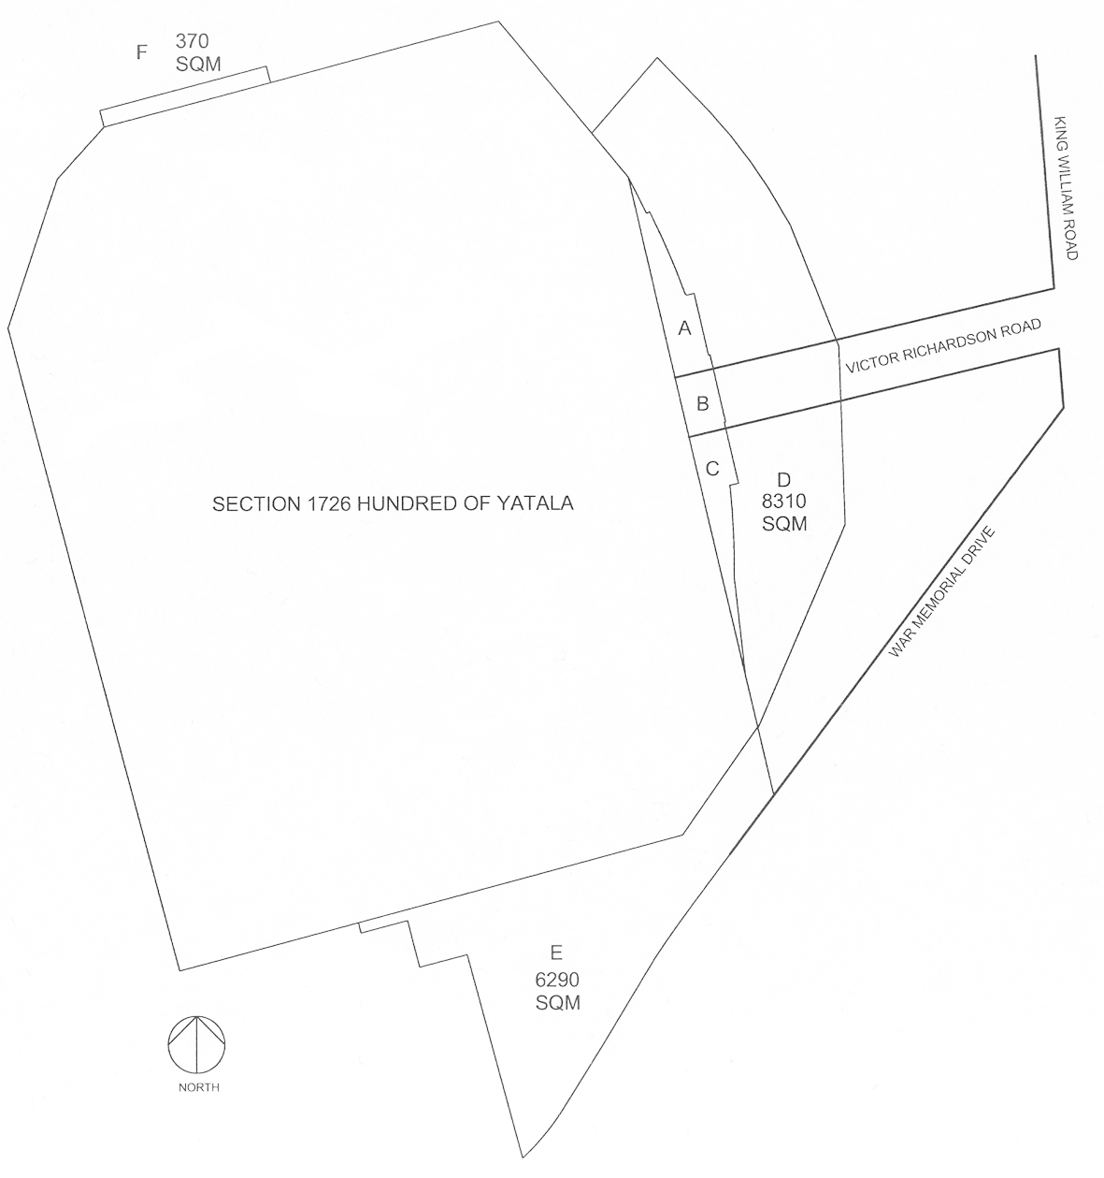

Schedule 2—Eastern Grandstand Area
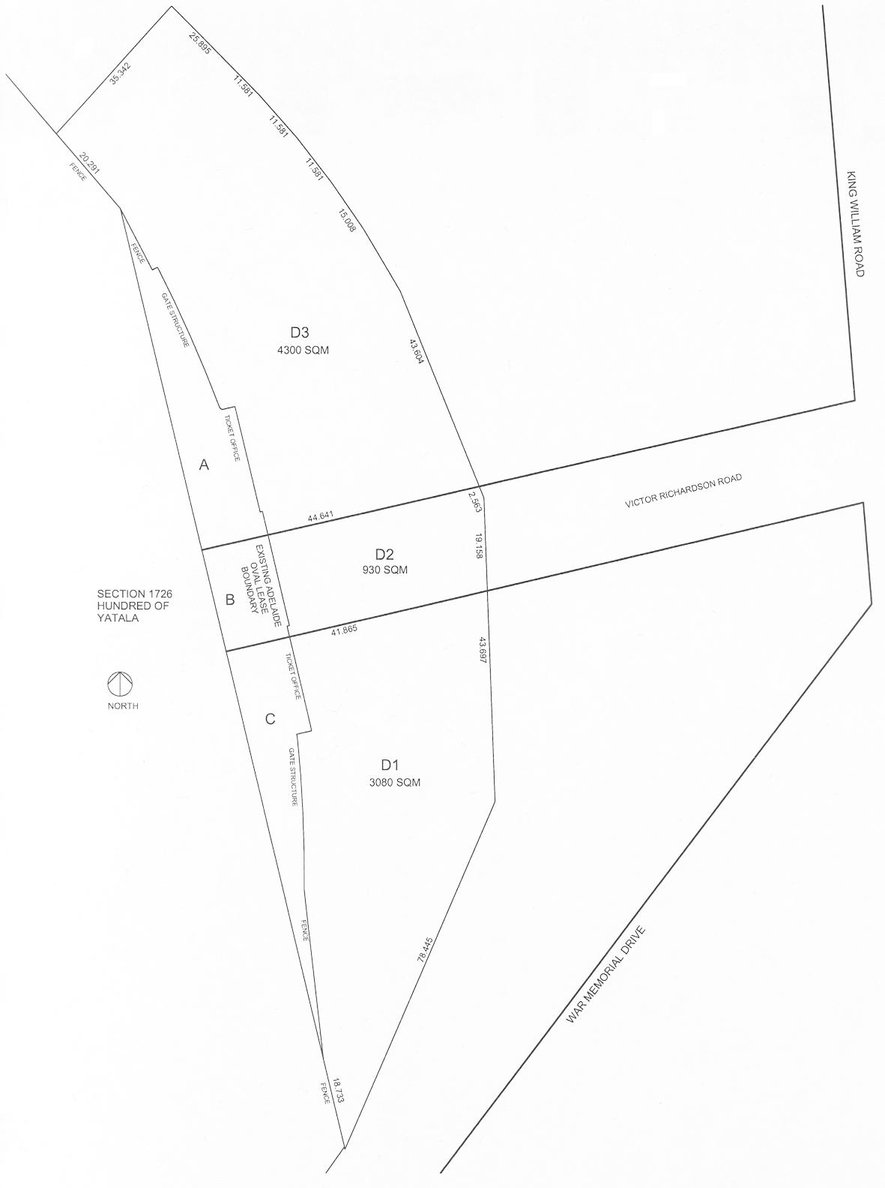

Schedule 3—Southern Area
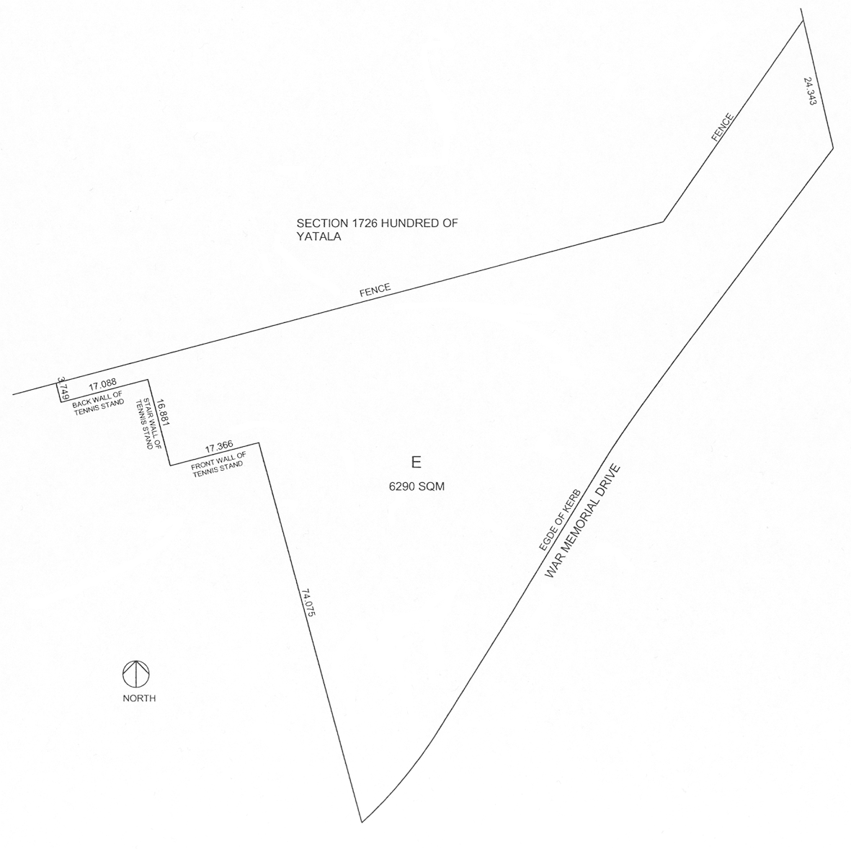

Schedule 4—Northern Area
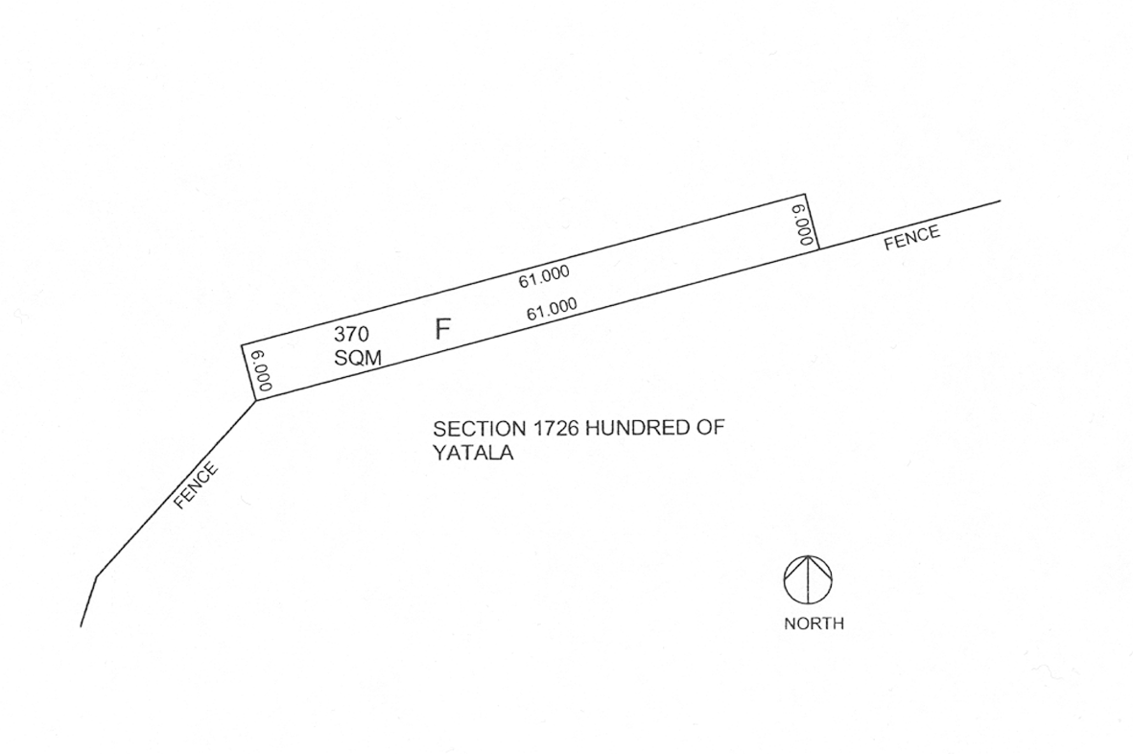

Schedule 5—Car parking area
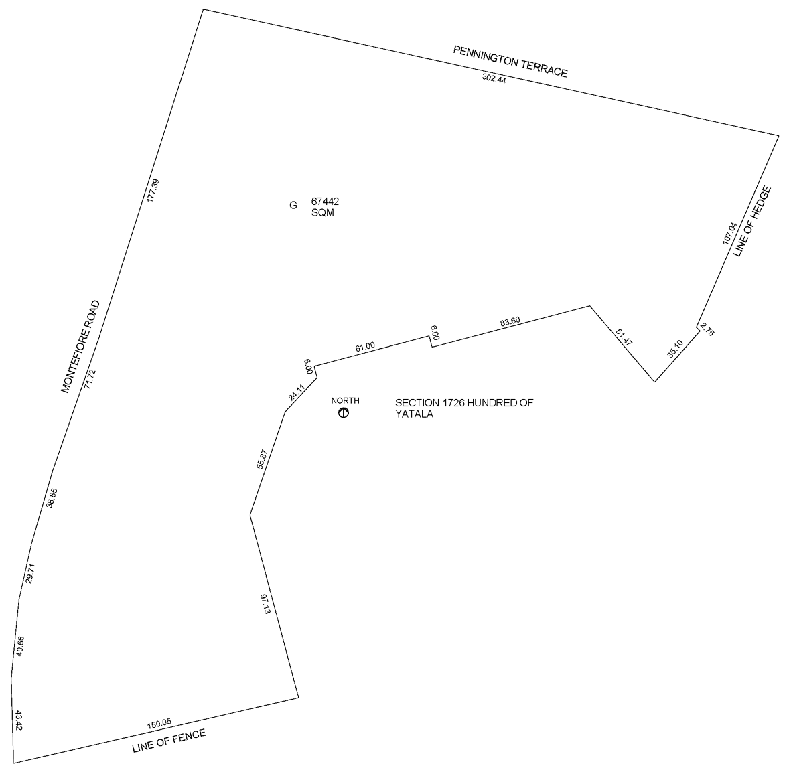

Legislative history
Notes
• Amendments of this version that are uncommenced are not incorporated into the text.
• For further information relating to the Act and subordinate legislation made under the Act see the Index of South Australian Statutes or www.legislation.sa.gov.au.
Principal Act and amendments
New entries appear in bold.
Year | No | Title | Assent | Commencement
2011 | 29 | Adelaide Oval Redevelopment and Management Act 2011 | 4.8.2011 | 29.9.2011 (Gazette 29.9.2011 p4136)
2017 | 5 | Statutes Amendment (Planning, Development and Infrastructure) Act 2017 | 28.2.2017 | Pt 3 (ss 11—14)—uncommenced

